Advanced Topics in Neuroscience HW4

Aliakbar Mahmoodzadeh 98106904

1. **the most dominant frequency oscillation:**

Raw data have a 1/f spectrum on their power spectrum which is called pink noise. Pink noise should be removed because it makes lower frequencies have high powers. In order to remove the pink noise, I’ve calculated the power spectrum for each trial of each Electrode. Then we fit a line to the log-log power spectrum of each signal. It is the result of the fitted line(I’ve plotted the crude signal and signal without noise for each electrodes)

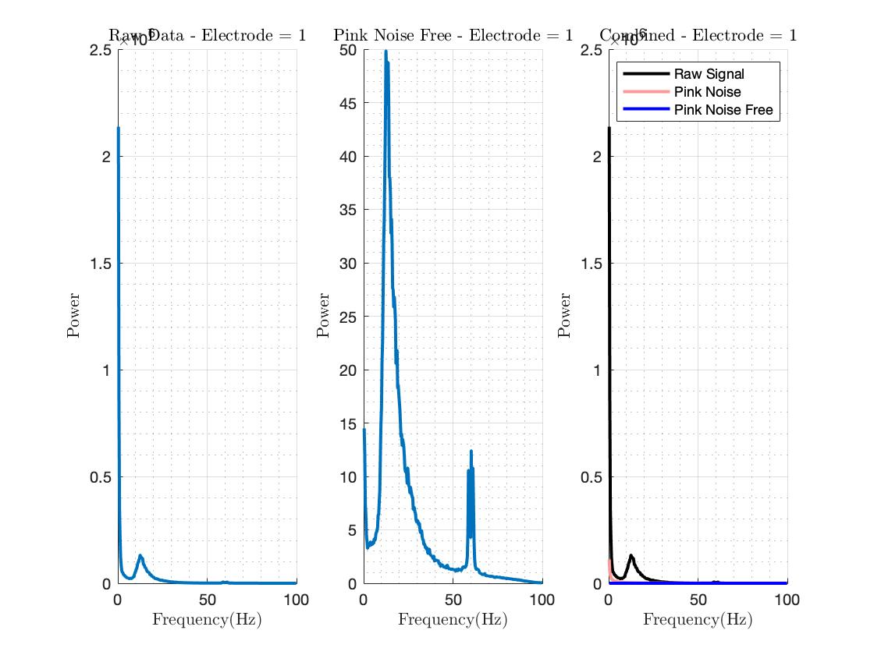

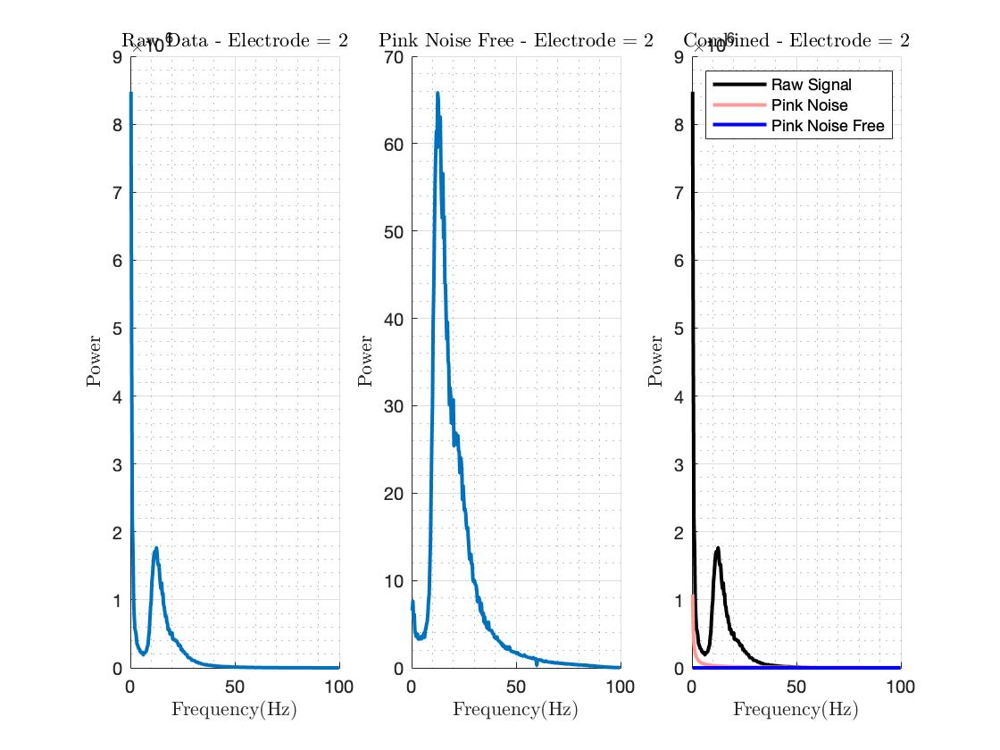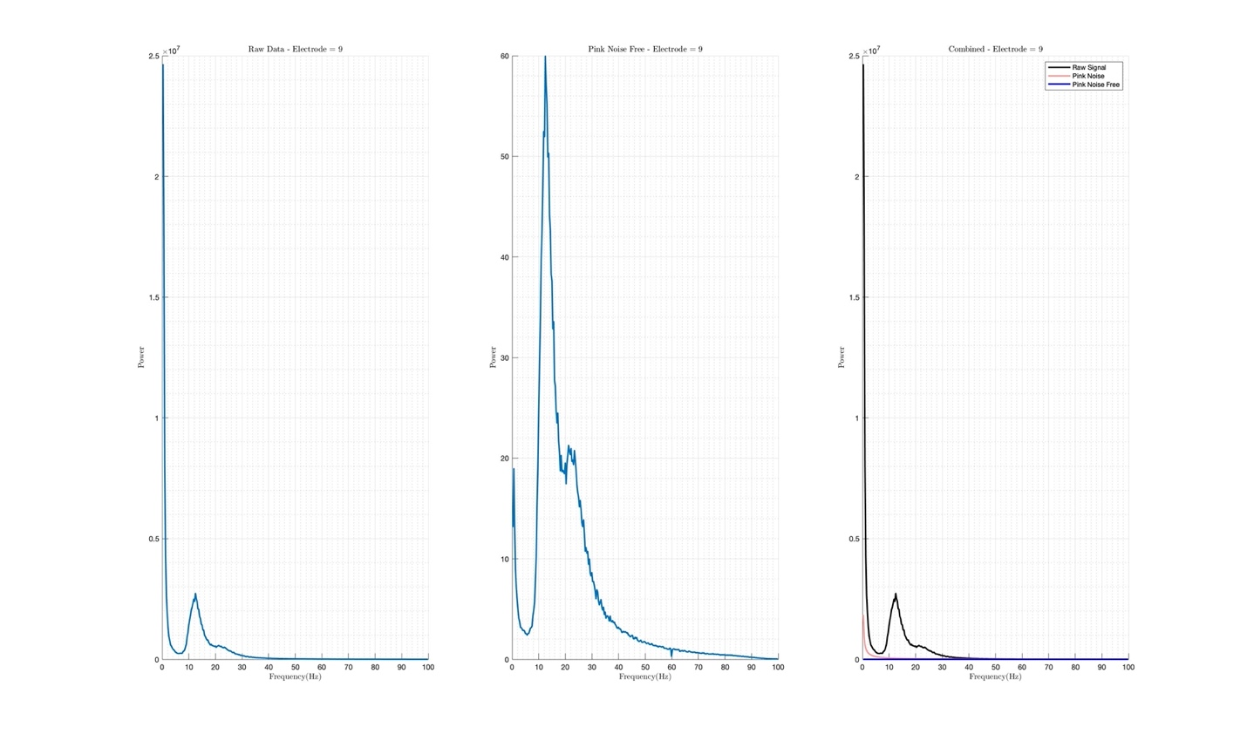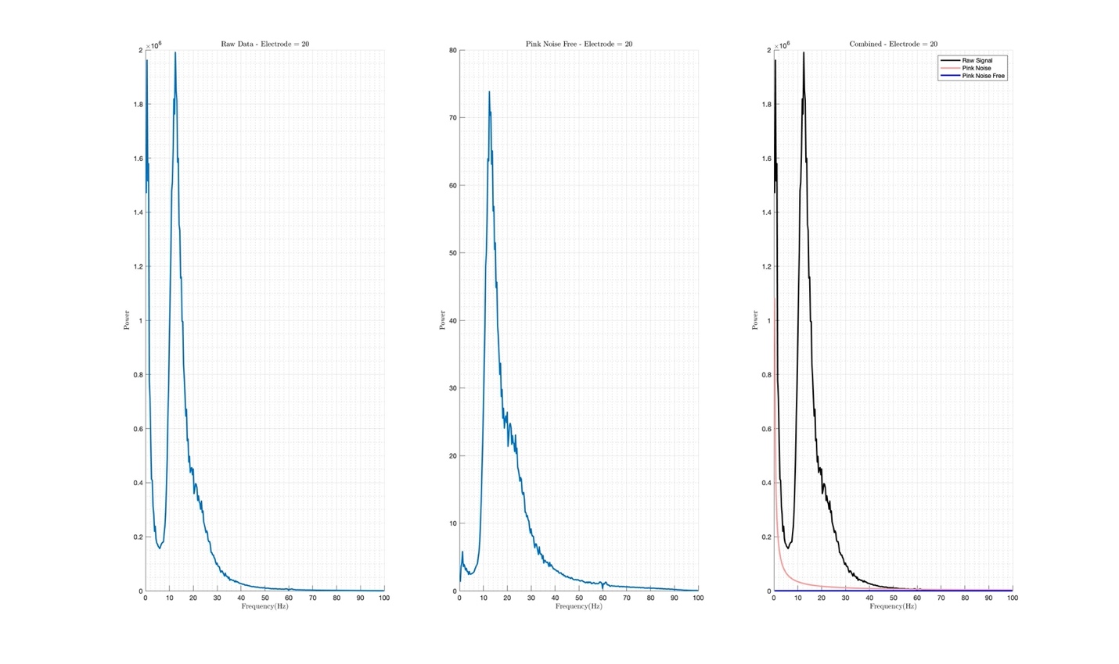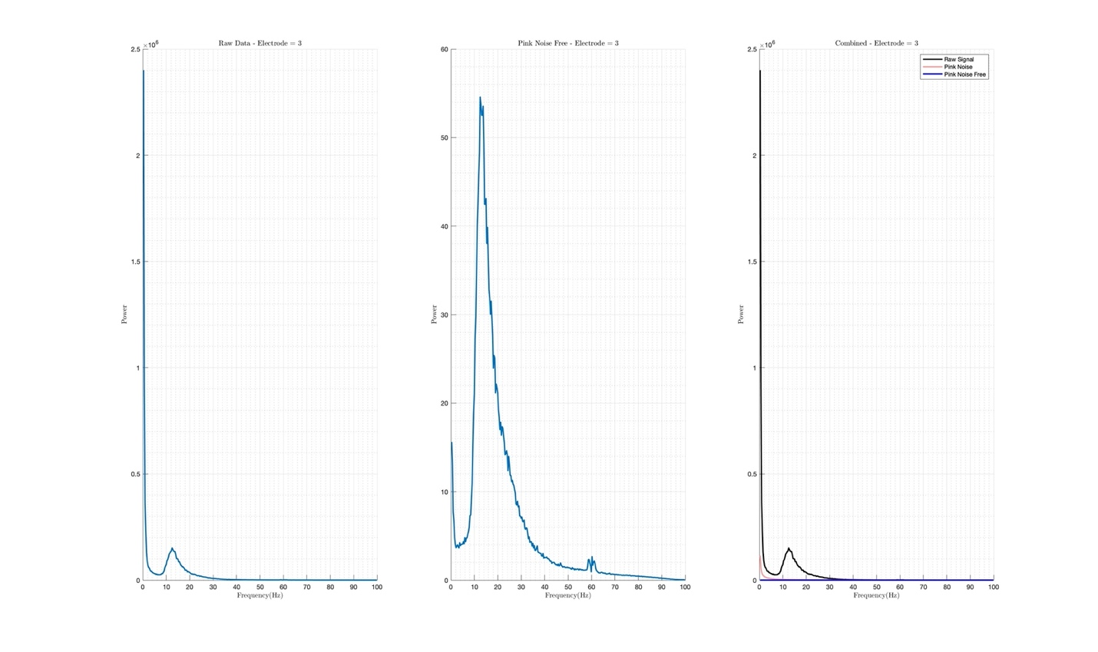

In these plots, you can see the power spectrum which its showing that this electrode has a dominant frequency of around 13-13 Hz.

Also I’ve plotted the power spectrum averaged over all trials of all electrodes:

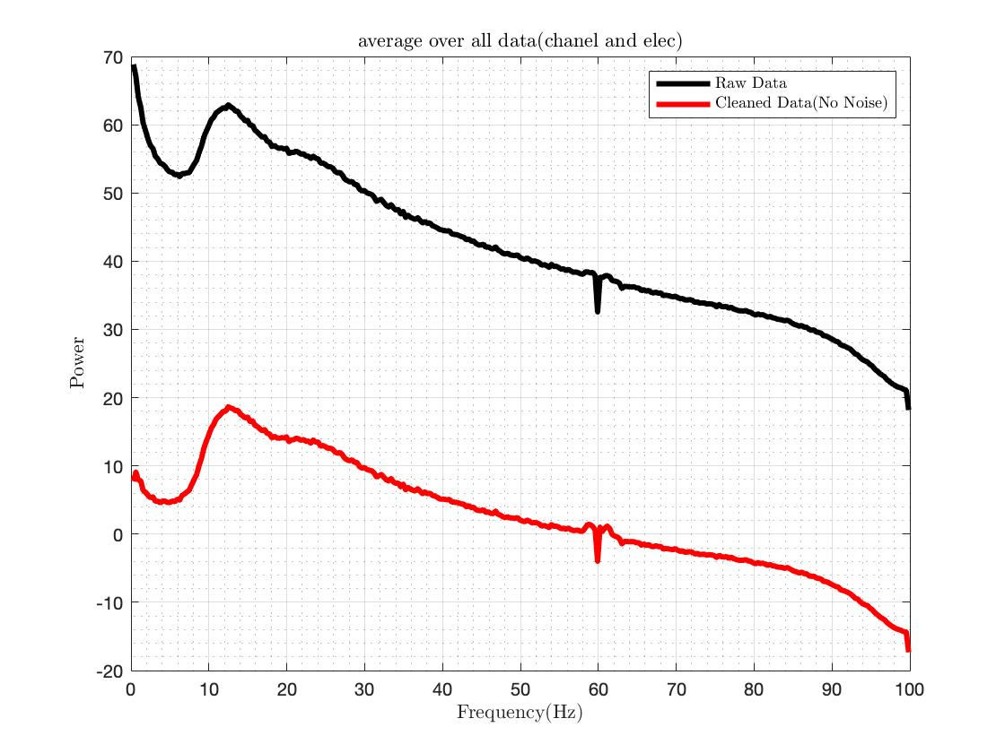

After Pink noise cancellation, I’ve extracted the dominant frequencies by considering the global maximum of the result. Then I plotted the result:

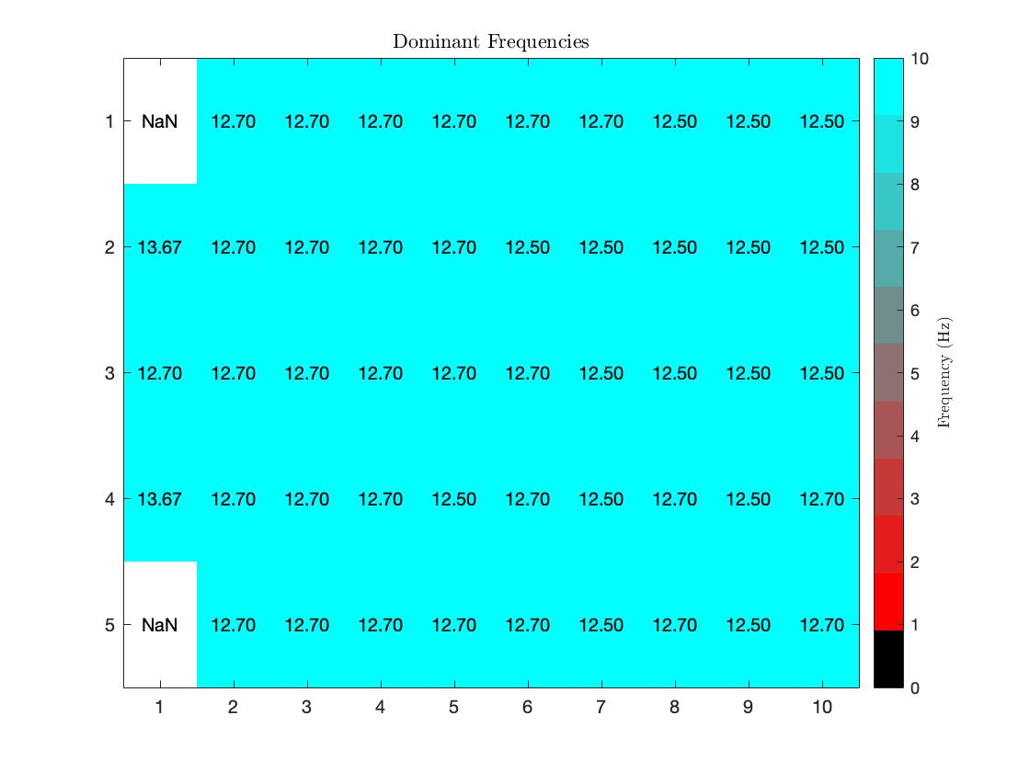

And I plotted the bar graph to show how many electrodes does some Frequency Range:

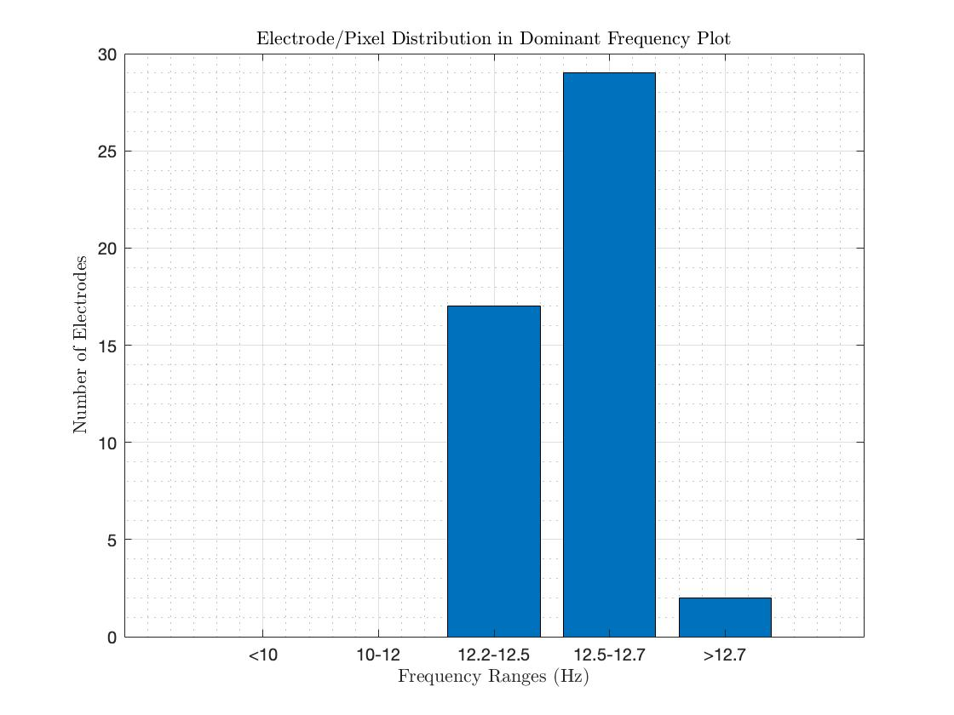

As you can see in the above bar graph, so many electrodes have a dominant frequency between 12.5~12.7, so we can chose this frequency as the dominant frequent

1. **Cluster electrode group based on their dominant oscillation frequency**

Many of electrodes’ frequency dominants were 12.5 Hz but less than 10 electrodes which is 12.7 or more than 13 Hz. This is a phenomenal result and consequently we can put all electrodes in one cluster. So we put all electrodes in one cluster and dominant oscillation frequency is 12.5 Hz approximately.

1. **Plot power spectrum of LFP signals through the time.**

First of all, we use modern and advanced technique like Welch method, and here is the result:

For raw data:

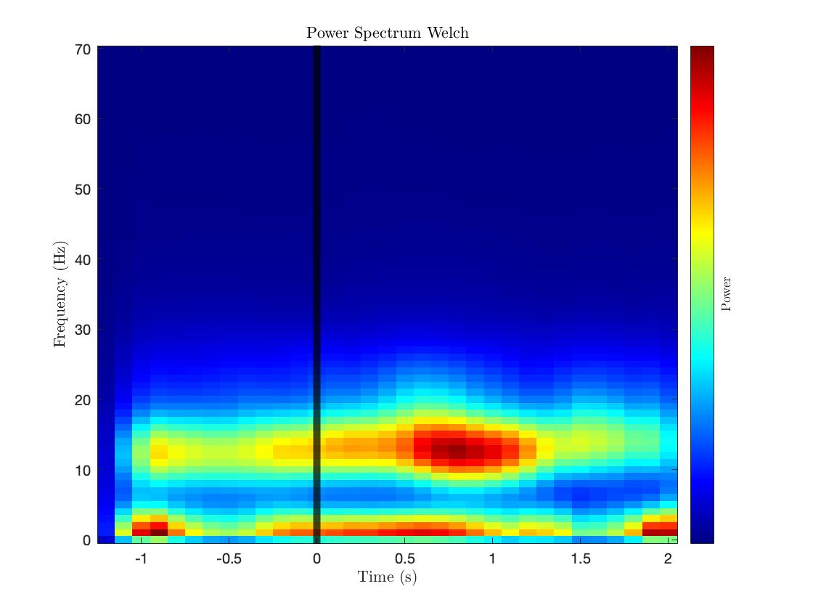

For filtered data:

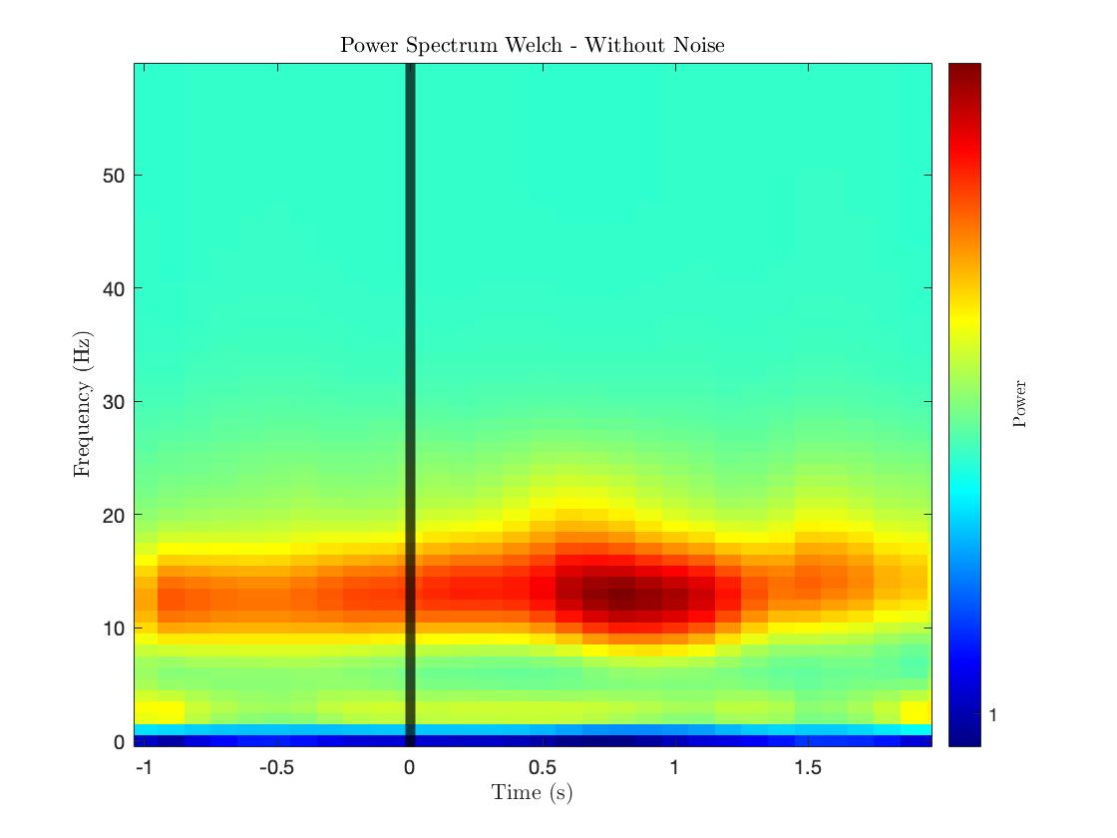

The plots above are shown for raw and clean data (without pink noise), respectively.

Explain the plots: As can be seen in the plot, after 500ms of the onset there is an increase in the power of the 10~15Hz frequency band.

After Welch method, I use the Multitaper method. This is the result for raw data:

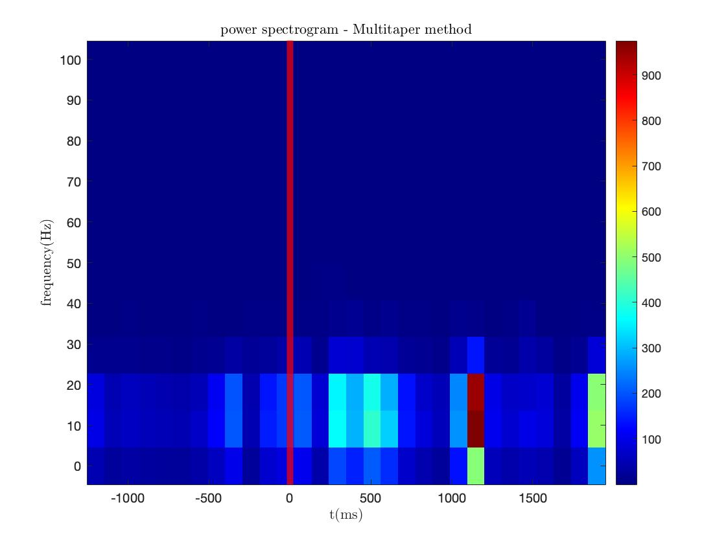

Explain the graph: Also this time it is more visible that we had some activity in the 5Hz to 25Hz before the stimulus onset, and right after the stimulus onset, the power falls and again rises till about 1200ms.

1. **Compare your result with Hatsopoulos et.al 2006**

The results indicate that the signal's power is more pronounced and undergoes more significant changes in the frequency range of 10-25 Hz compared to other frequency ranges. This means that the signal has a stronger power in both the Beta band (10-25 Hz) and the Gamma band.

In the figure provided by Hatsopoulos, a similar effect can be observed in the Beta band (10-25 Hz).

Plot by me VS Plot by Hatsopoulos et.al 2006:

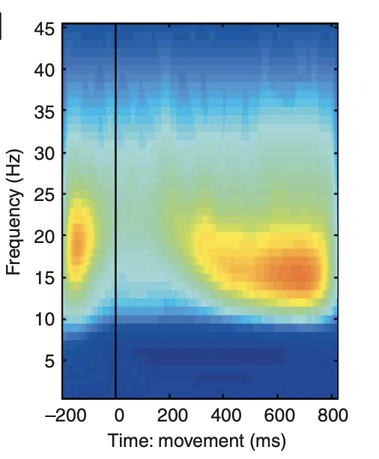

1. **band-pass Butterworth filter (I suggest 2nd order!)**

in order to filter the signals, I’ve used a 2nd order band pass Butterworth filter that pass the component of the signal around the dominant frequencies 12.5 Hz, we design a 2nd order Butterworth filter with fc =12.5 Hz and bandwidth of 1.5 Hz. So we band pass the signals from 11 to 13 Hz.

This is the Filter:

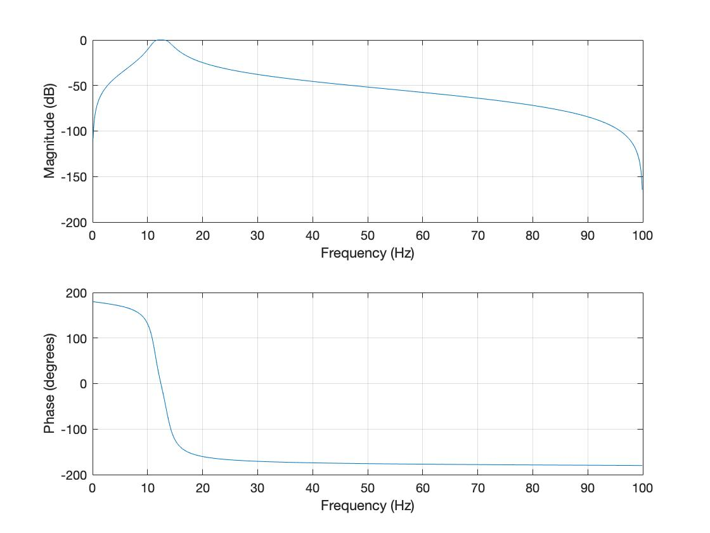

After that I applied this filter to all data so I plot it for each electrode average over all trials, and here is some plot: 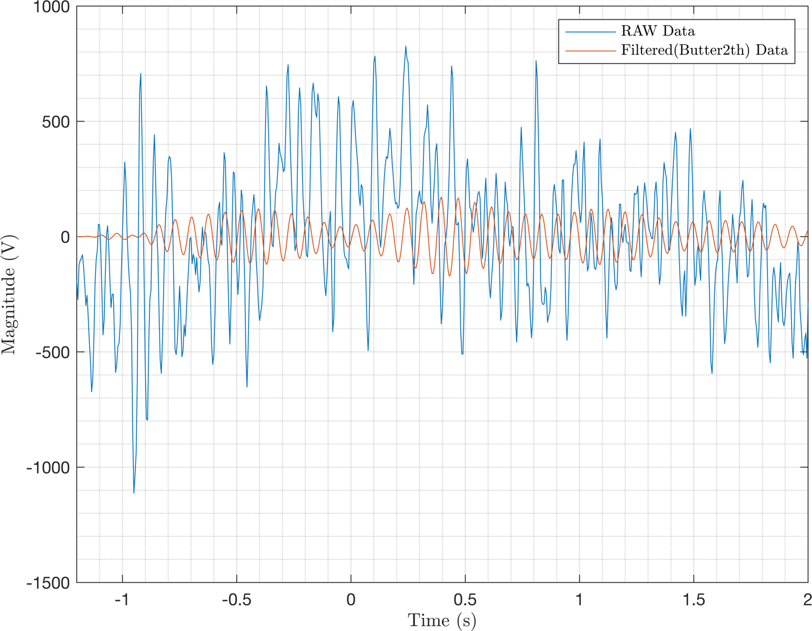

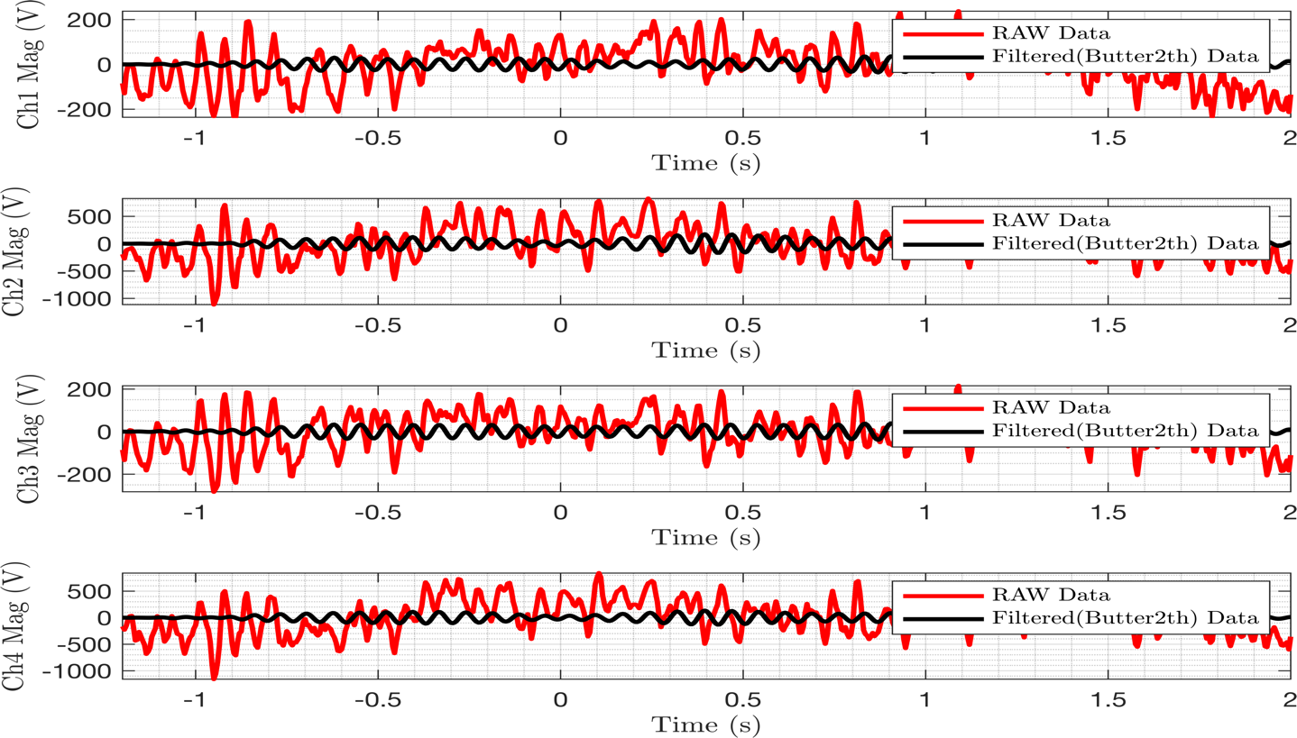

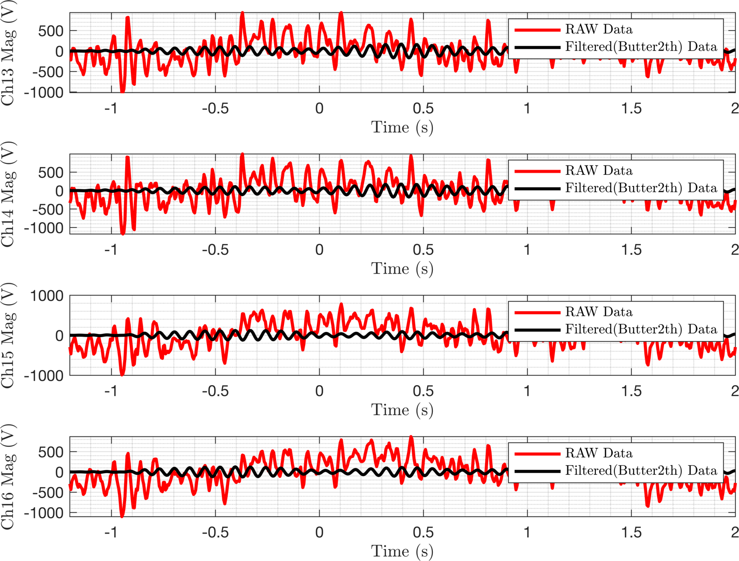

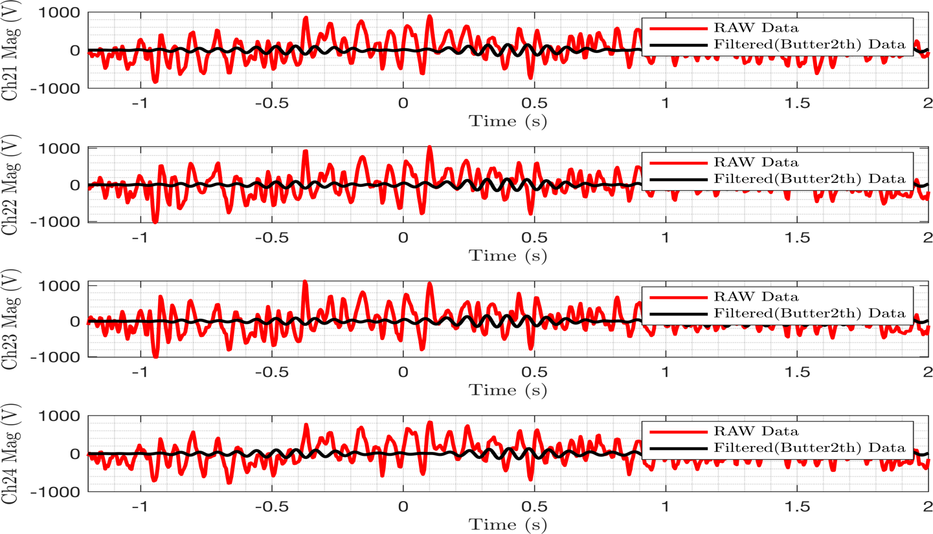

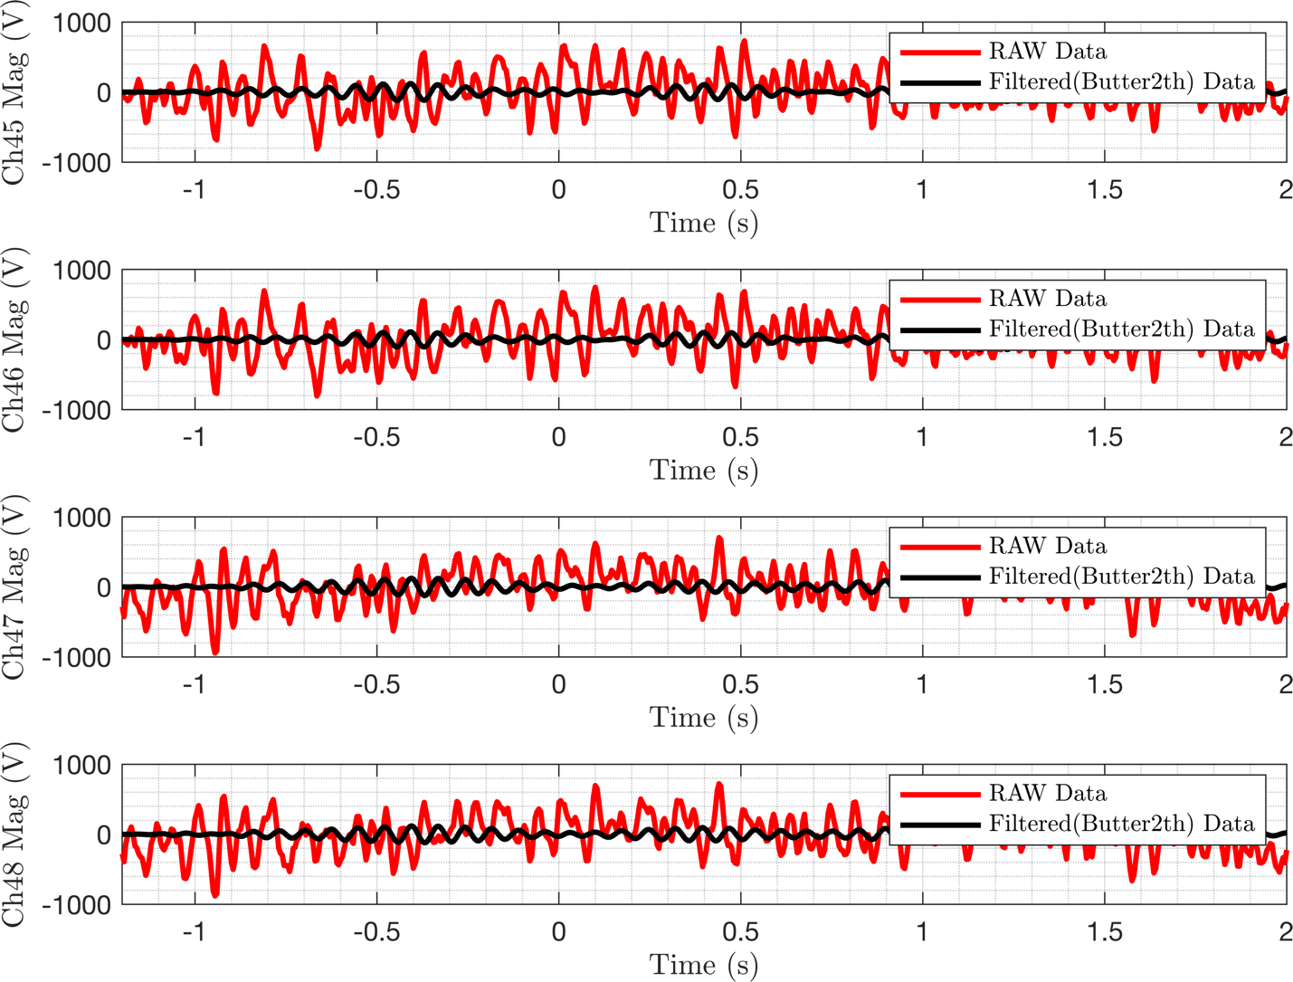

As you see by using the filter we can delete the drift of the raw signal, and our filtered signal is more smooth than the raw data

1. **calculate instantaneous phase of filtered signals**

The signals are filtered using a Butterworth filter of 2nd order at 1hz around the dominant frequency. The instantaneous phase is calculated by the equations below by using Hilbert transformation:

**φ(t) = arg[Sa(t)] = arg[s(t) + jsˆ(t)]**

1. **design a demo to show the COS(𝜙(𝑥, 𝑦,𝑡))**

By taking the cosine of the instantaneous phase of each electrode of a selected trial (first trial), we plot the calculated cosine over time:

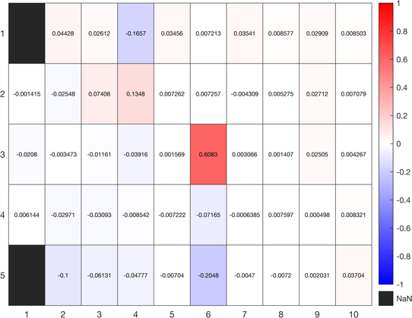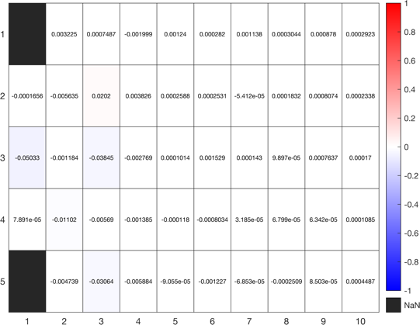

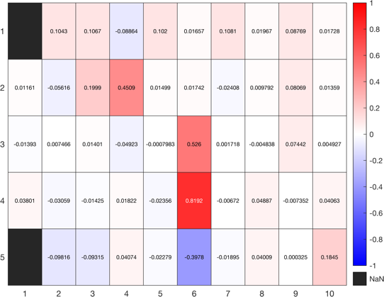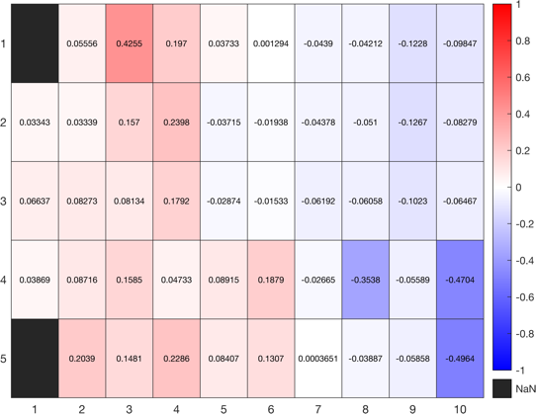

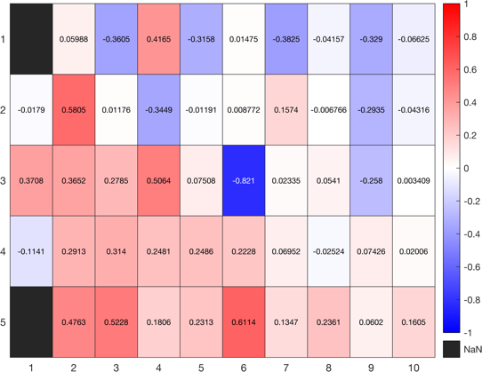

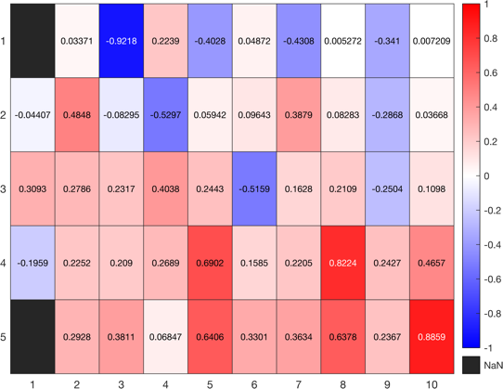

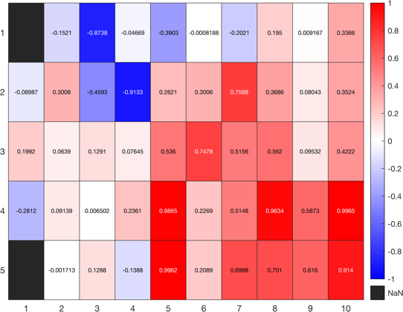

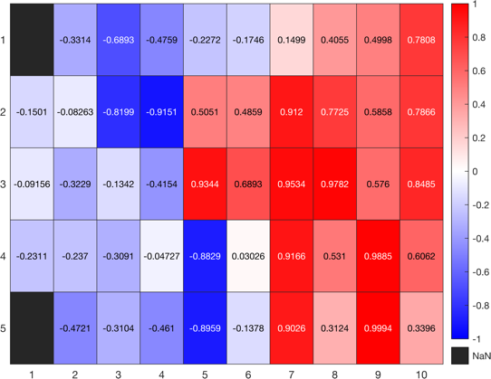

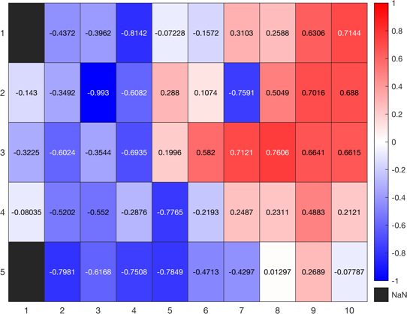

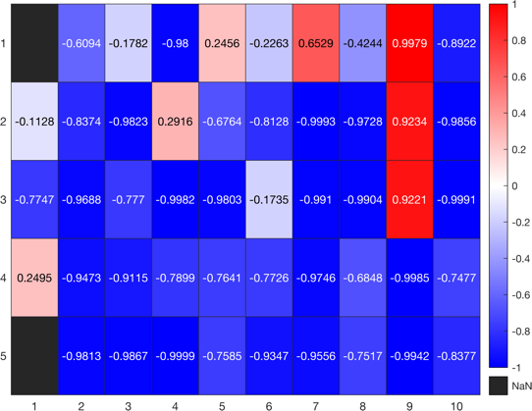

Seems that the wave starts form right to left.

1. **calculate the Phase Gradient Directionality**

To calculate the Phase Gradient Descent (PGD), follow these steps:

1. First, compute the gradient of the cosine(angle) between neighboring electrodes.
2. Next, calculate the norm (magnitude) of the mean gradients and the mean of the norms. The PGD is defined as the ratio of these two values (norm of the mean gradients divided by the mean of the norms).
3. After the calculations, you'll obtain a PGD value for each time point in a trial.
4. To visualize the distribution of the PGD values, create a histogram plot. The histogram displays the frequency of PGD values within specific ranges, giving you an idea of how the PGD values are distributed across the trial.

In summary, the process involves computing the gradient of the cosine(angle) between neighboring electrodes, calculating the PGD values for each time point, and then visualizing the distribution of these values using a histogram plot.

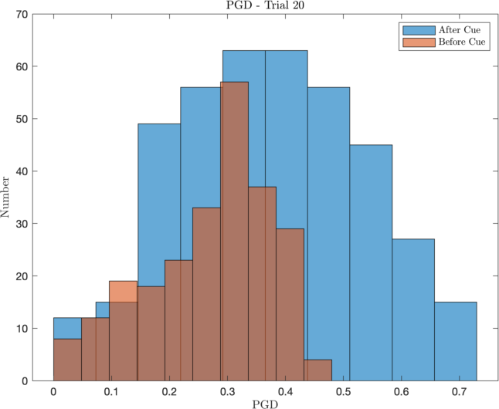

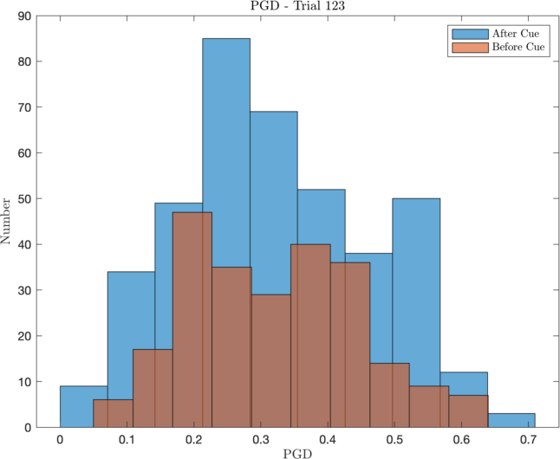

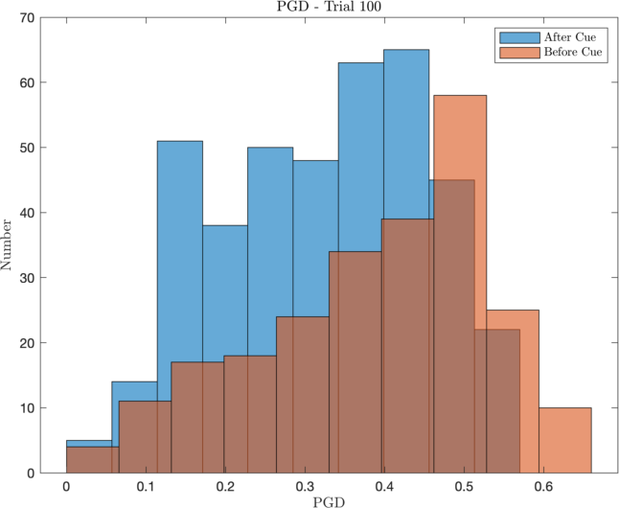

For direction of propagation, I’ve plotted the direction of gradient in each channel

For calculating the speed of propagation, we use this equation:

$$speed⁡(t)=|\overline{(∂φ/∂t)}|/\overline{∥∇φ∥}$$